**Describe copes for Spring beans? What is the default scope?**

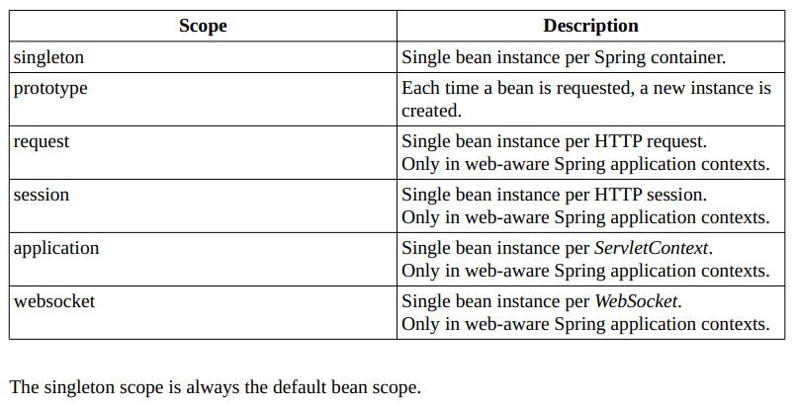

<https://www.baeldung.com/spring-bean-scopes>

**Can you describe the lifecycle of a Spring Bean in an ApplicationContext?**

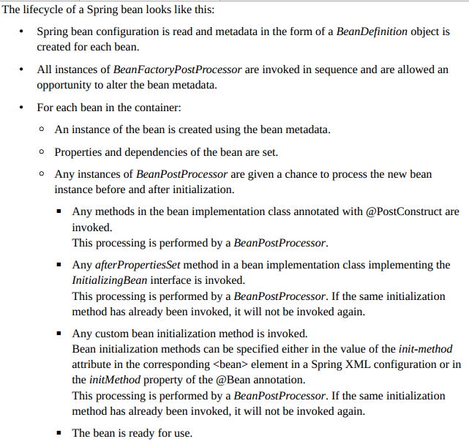

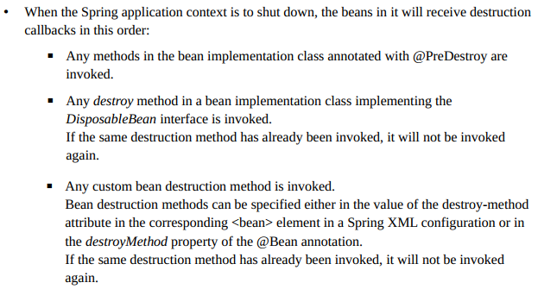

**Describe BeanDefinition.**

<https://docs.spring.io/spring/docs/5.0.3.RELEASE/spring-framework-reference/core.html#beans-definition>

**What is a BeanFactoryPostProcessor and what is it used for? When is it invoked?**

<https://docs.spring.io/spring/docs/5.0.3.RELEASE/spring-framework-reference/core.html#beans-factory-extension-factory-postprocessors>

<https://docs.spring.io/spring-framework/docs/current/javadoc-api/org/springframework/beans/factory/config/BeanFactoryPostProcessor.html>

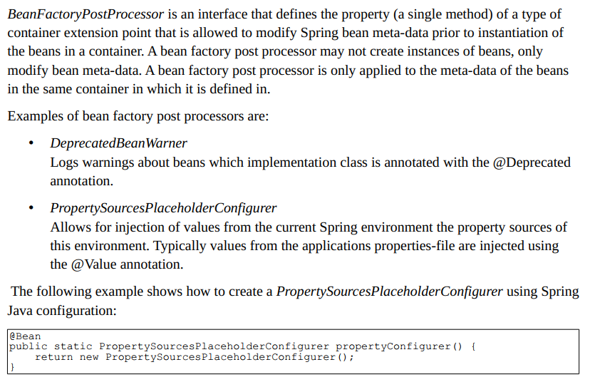

**When is a bean factory post processor invoked?**

BeanFactoryPostProcessor implementations are "called" during startup of the Spring context after all bean definitions will have been loaded.

**What is a BeanPostProcessor and how is it different to a BeanFactoryPostProcessor? What do they do? When are they called?**

<https://docs.spring.io/spring/docs/5.0.3.RELEASE/spring-framework-reference/core.html#beans-factory-extension-bpp>

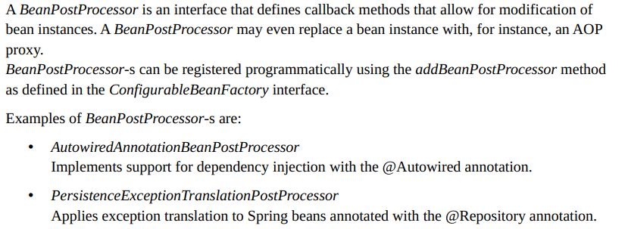

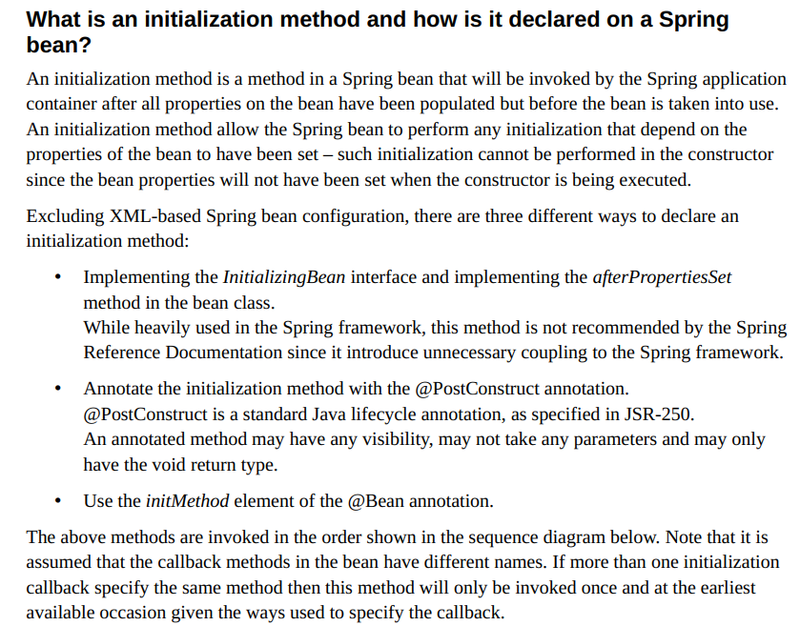

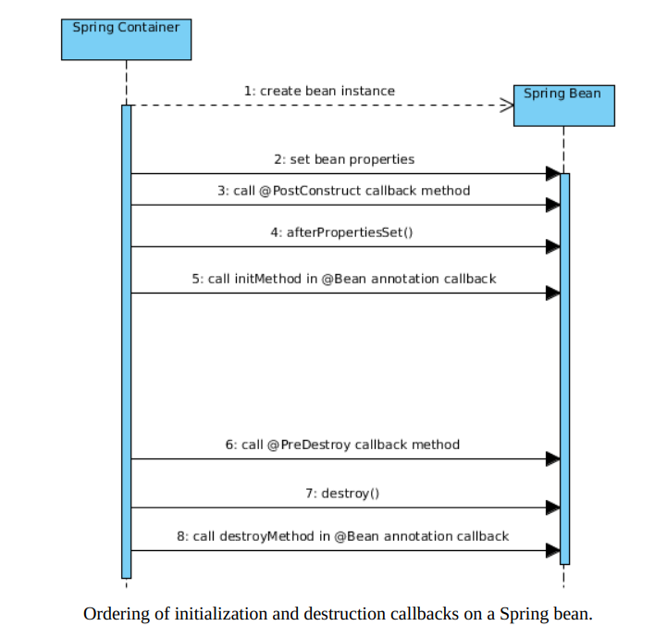

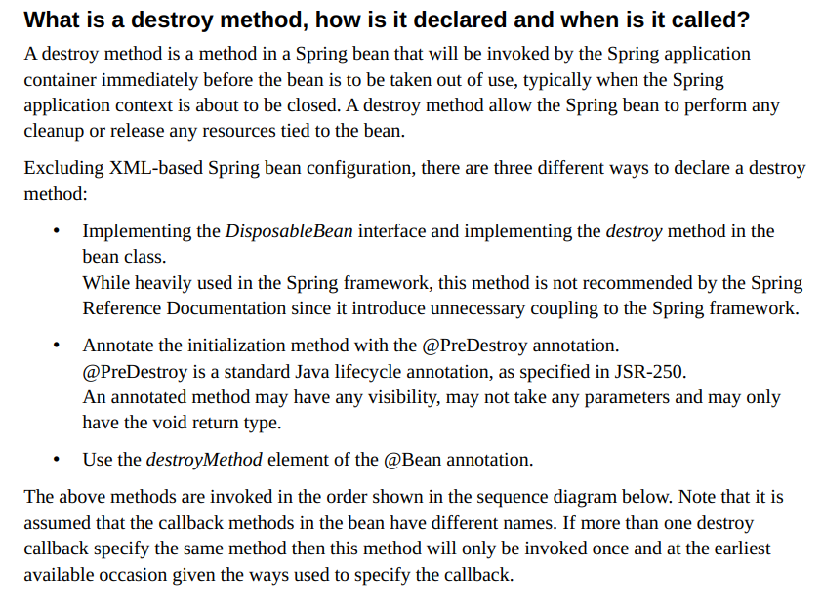

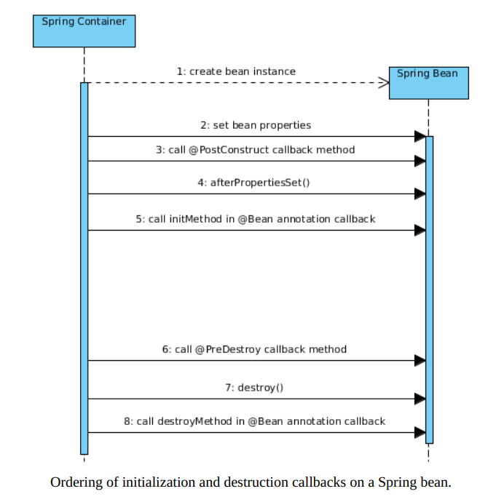

**How else can you define an initialization or destruction method for a Spring**

**bean?**

Only these methods are available.

